**WEBFORMS SIMPLILEARN PROJECT**

**SAIVIGNESH P**

**Overview**

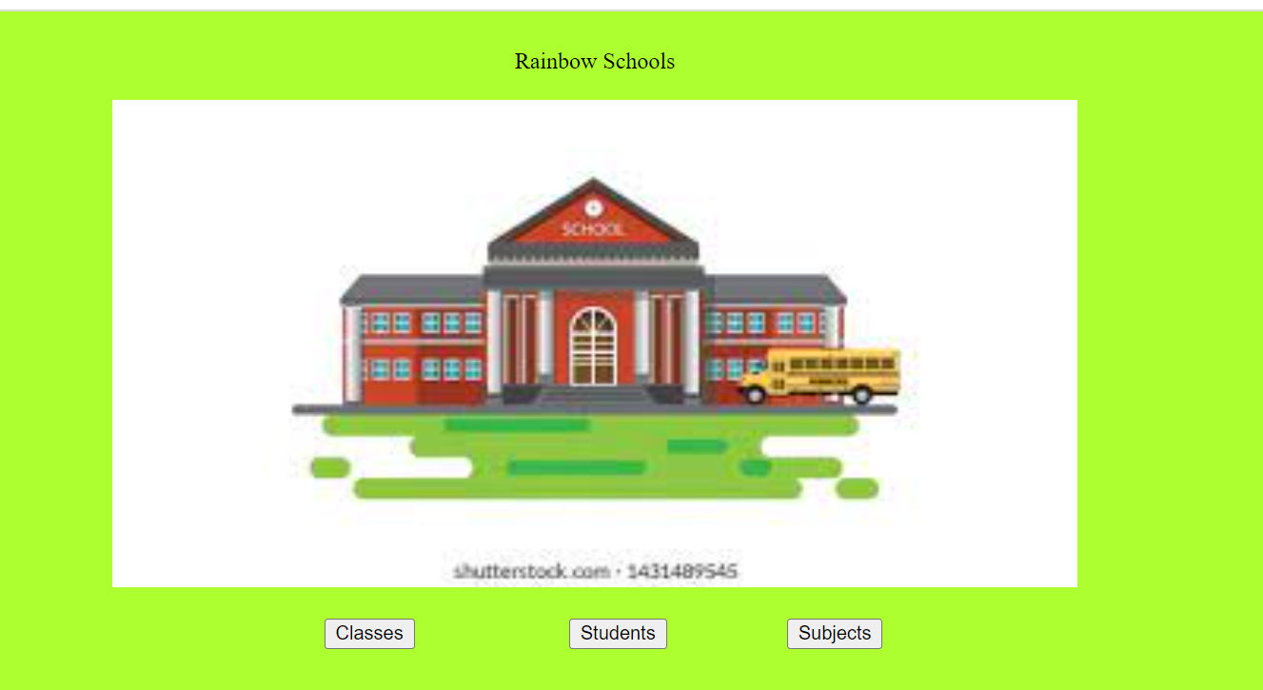

**Classes**

**Insert**

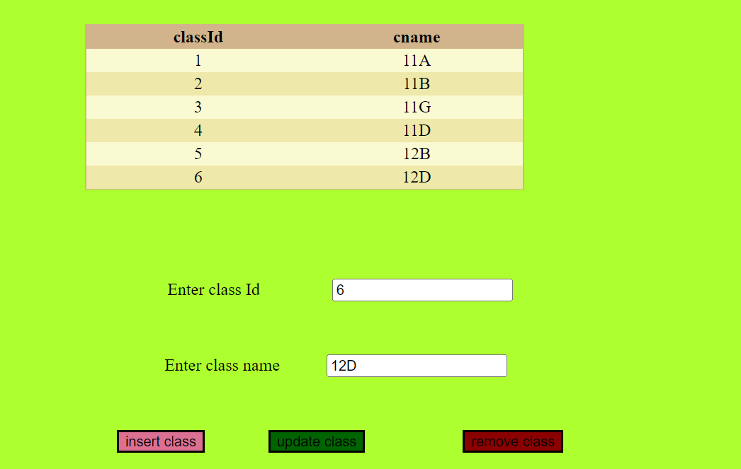

**Update**

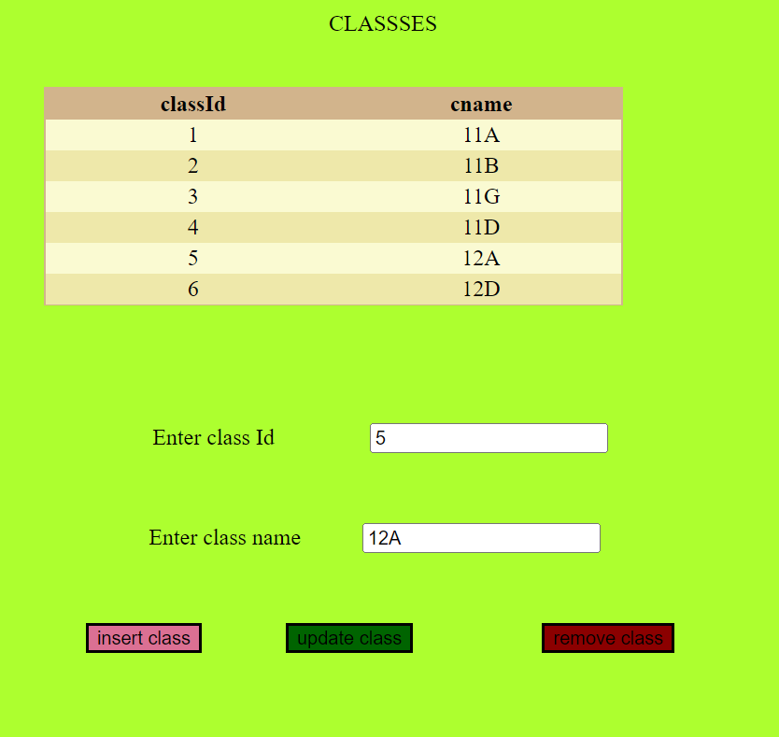

**Delete**

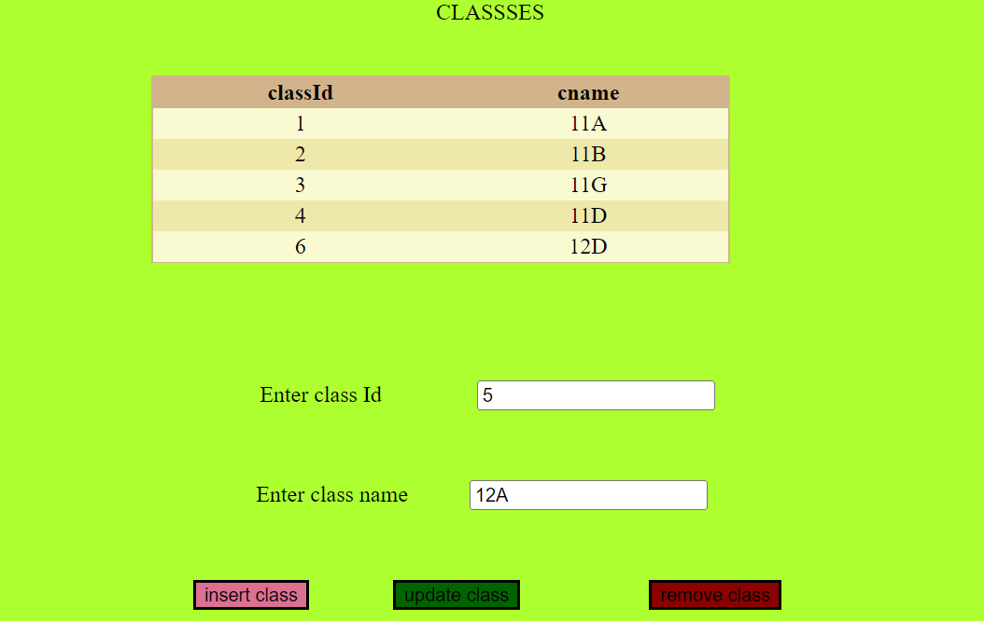

**Students**

**Insert**

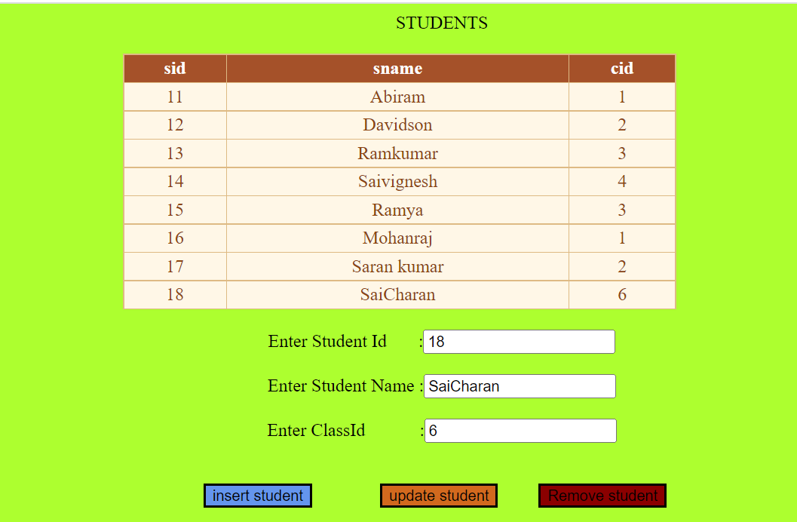

**Update**

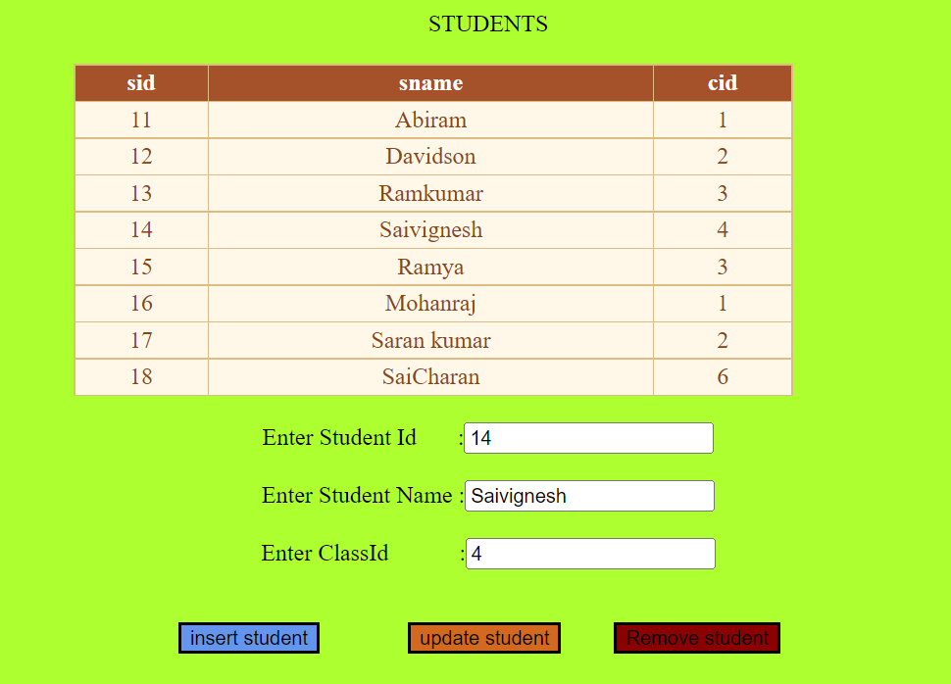

**Delete**

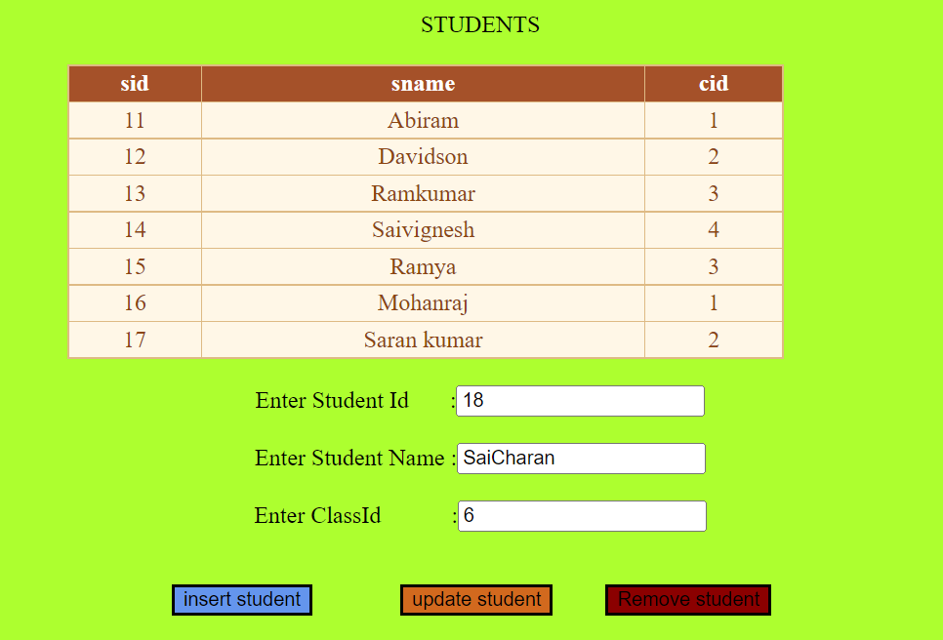

**Subjects**

**Insert**

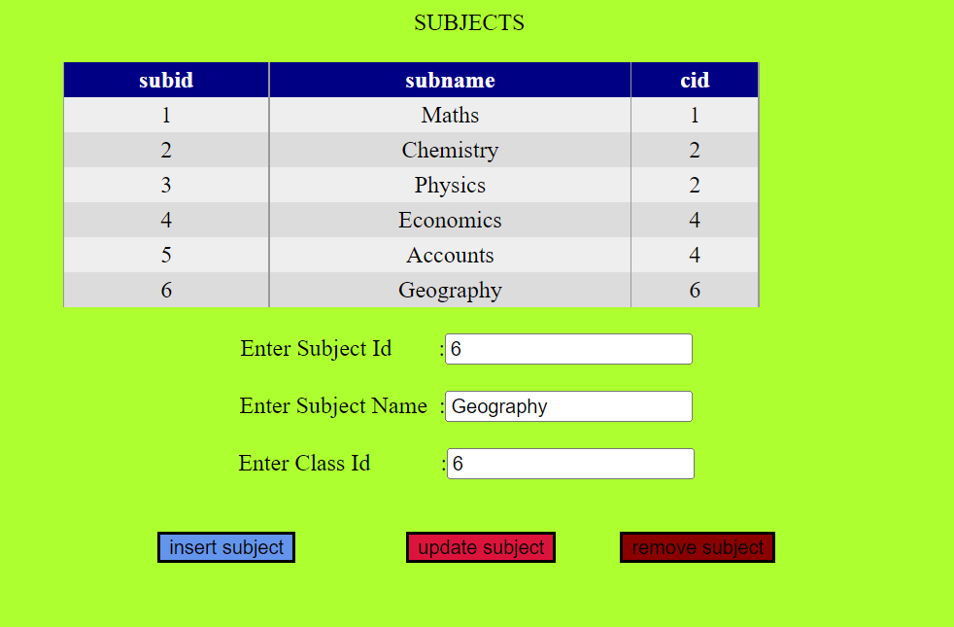

**Update**

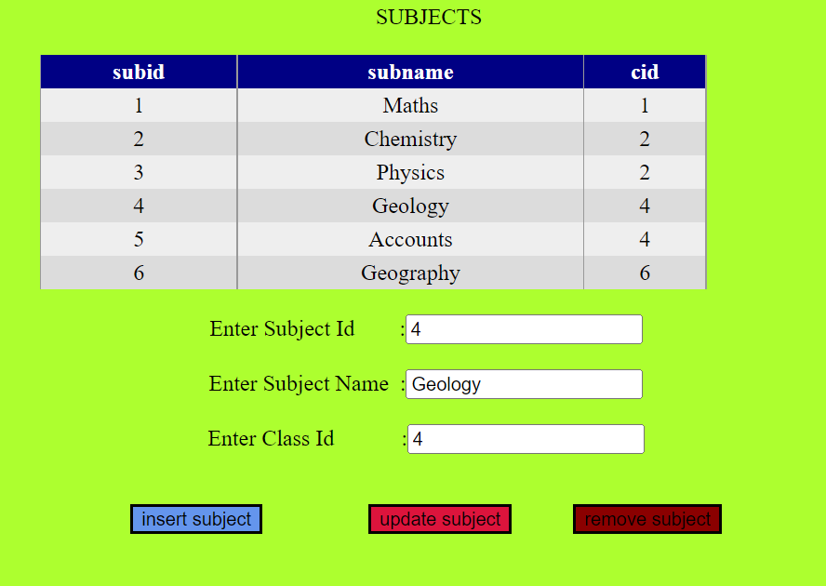

**Delete**

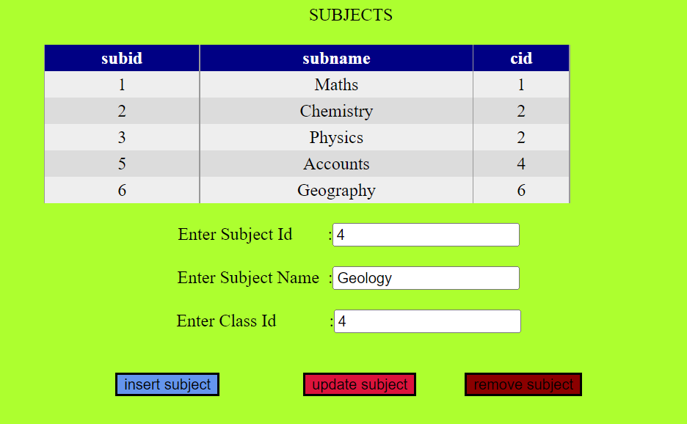

**Link for a project**

[**https://github.com/saivignesh2001s/simplilearnprojectwebforms**](https://github.com/saivignesh2001s/simplilearnprojectwebforms)